Assignment

**1. Create a blog or website using Blogspot and WordPress. Customize the theme design and post new article with 500 words.**

[**https://anardana12.blogspot.com/2023/10/robust-anardana-powder.html**](https://anardana12.blogspot.com/2023/10/robust-anardana-powder.html)

**2. Create a New Facebook Business Page and post one social media poster for your brand.**

[**https://www.facebook.com/profile.php?id=61552695700002&mibextid=ZbWKwL**](https://www.facebook.com/profile.php?id=61552695700002&mibextid=ZbWKwL)

**3. Create and design a social media advertisement poster using canva.**

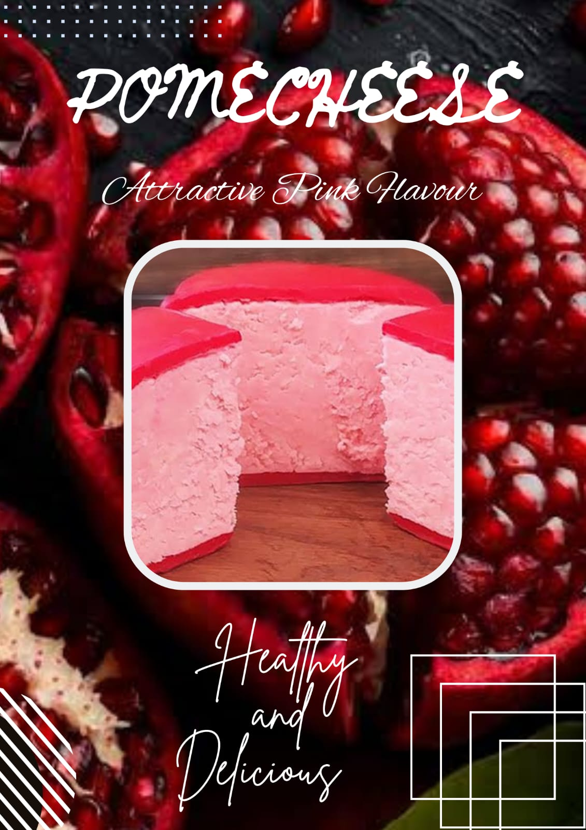

**<https://m.facebook.com/story.php?story_fbid=pfbid02Nu2iGnfPCkAsc3h47iCXEB6TxQh3XRKqUmSMvhPvLZBLh8VJ5N5yHinnzvwhHzJgl&id=61552695700002&sfnsn=wiwspwa&mibextid=RUbZ1f>**

**4. Create email newsletter design using MailChimp or canva tool.**

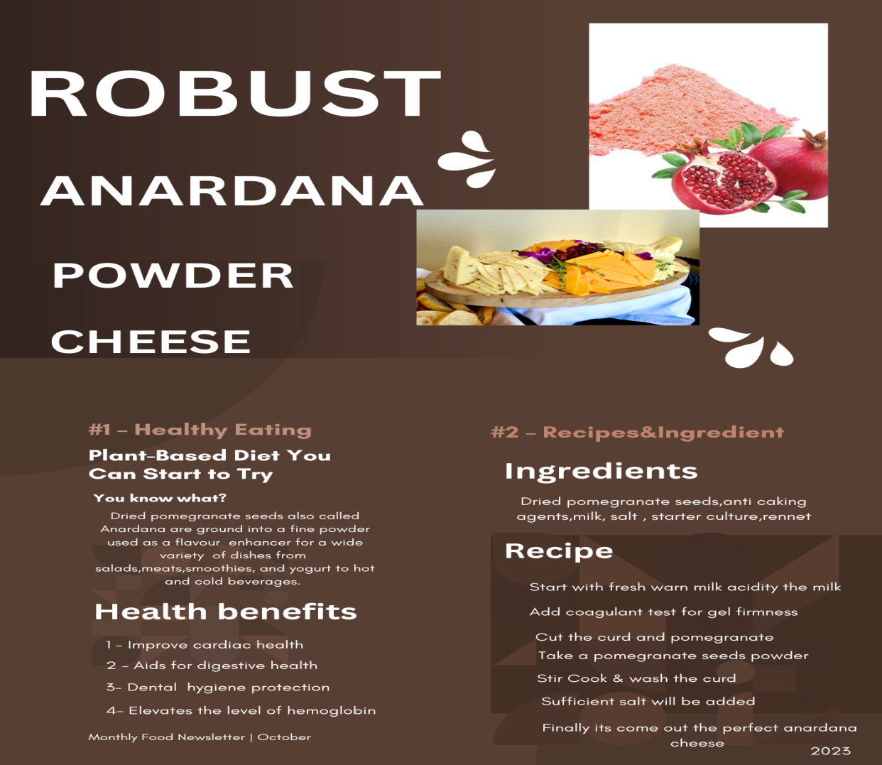

[**https://www.facebook.com/61552695700002/posts/pfbid026frihRzkMV8E5FBLdbbFymGsjdij6cJ6nzQ4mMcgEbuuAumibXk167bvWTadAXAbl/?mibextid=Nif5oz**](https://www.facebook.com/61552695700002/posts/pfbid026frihRzkMV8E5FBLdbbFymGsjdij6cJ6nzQ4mMcgEbuuAumibXk167bvWTadAXAbl/?mibextid=Nif5oz)